Akhil Garg
BNFO 300
December 6, 2014

Proposal: Measurement of the relative binding of Ang-4 to the Tie-2 receptor

Introduction
The stability of blood vessels in the human body is in dynamic equilibrium: on one hand, vessels must allow small molecules in and out of capillaries, and on the other, blood serum must not leak out. This equilibrium changes as body conditions change, especially during disease. For example, during the process of inflammation, vessels become unstable and release more blood (Kennedy, 2010; Prevete, 2013). The blood, which is full of proteins and antibodies, helps to fight infection. Physical outcomes of other diseases—such as sepsis (Standiford, 1995), metastasis of cancers (Padua, 2008), and viral hemorrhagic infections like Ebola (Terajima, 2007)—also depend on the regulation of vessel stability. Some of these conditions are quite dangerous and need urgent treatment.
A better understanding of the mechanisms that influence capillary stability could lead to better, faster treatment for these diseases. For instance, a drug that decreases capillary permeability during sepsis could lead to better patient outcomes. The creation of such a therapy depends on comprehending the signaling pathways that control blood vessels.

The Tie-2 pathway
A tyrosine kinase is a signaling molecule. Tyrosine kinases are activated by ligands, in which case they add a phosphate group to a tyrosine residue of another protein, which in turn activates or deactivates the other protein. This process may trigger a signaling cascade (Hellmut, 2009).
The tyrosine kinase Tie-2 regulates the later steps of angiogenesis (the formation of new blood vessels) and vessel stability (Gale, 1999; Hellmut, 2009). Endothelial cells are cells that line the inner wall of blood vessels. Tie-2 influences endothelial cells in numerous ways.
The activation of Tie-2 causes endothelial cells to proliferate, which in turn causes vessels to have a greater diameter. After construction of the vessel, Tie-2 is deactivated, and the proliferation stops. During inflammation, Tie-2 causes endothelial cells to attract white blood cells and other proteins to the capillary wall, thus allowing the immune response to travel through the vessel to tissues. When Tie-2 is not activated, it causes endothelial cells to reduce the number of cell-to-cell connecting proteins, thus increasing vessel leakiness. Other functions of Tie-2 are also known (Hellmut, 2009).

Angiopoietins
It is known that four ligands (proteins) known as angiopoietins bind to Tie-2 to cause activation or de-activation of it (Jain, 2003). These four angiopoietins are numbered Ang-1 through Ang-4. Ang-1 (a Tie-2 agonist) and Ang-2 (a Tie-2 antagonist) are better studied than Ang-3 and Ang-4. Ang-3 and Ang-4 are homologous proteins found in mice and humans, respectively. Both may play a role in humans, and Ang-4 seems especially important in human lungs (Valenzuela, 1999; Lee, 2004). However, the effects of Ang-4 that distinguish it from the other angiopoietins are not known.
We can begin to understand the effects of Ang-4 by first comparing the protein’s binding affinity to Tie-2 to that of other angiopoietins. If four different ligands are influencing the Tie-2 receptor, it is necessary to determine each ligand’s role. A first step in determining the role of Ang-4 is to determine how influential Ang-4 is in influencing Tie-2 phosphorylation compared to the other angiopoietins.
One way to quantify the “influence” of Ang-4 is through measuring binding constants. A higher binding constant implies that two molecules are more likely to be bound together. The purpose of the experiment in this proposal is to generate these binding constants.

Experiment
To measure binding constants, the technique of surface plasmon resonance (SPR) can be used. SPR generates binding constants by using its namesake phenomenon, surface plasmon resonance. Briefly, as two molecules bind to each other on a thin piece of metal, light reflects differently off of the other side of the metal. This small change is measured and translated to a binding constant (O’Shannessy, 1993).

SPR Theory
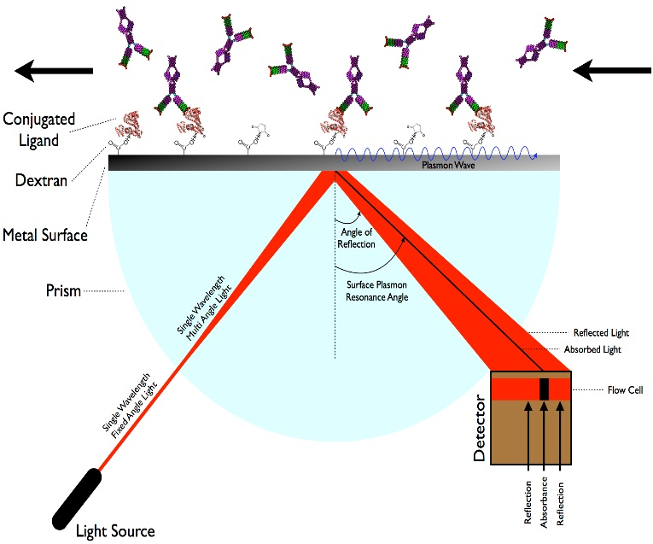
Metals have delocalized electrons on their surfaces—that is, electrons are able to move from one positive metal atom nucleus to another. These electrons move randomly about, but when a photon hits the surface of the metal, its electrons begin to oscillate at a certain frequency characteristic of the metal and whatever the metal is in contact with. A surface plasmon is a quantized oscillation of free electrons on the surface of a metal. SPR occurs when the frequency of a photon that hits the surface of a metal is the same as the frequency of the metal’s surface plasmons. A useful property of surface plasmons is that they influence the interaction of metals with light.
Figure 1: Surface plasmon resonance: the technique. The metal surface is gold, and instead of a prism, a simple piece of glass and a wide-angle light beam will be used. Tie-2 is bound to the dextran medium. As angiopoietins bind to Tie-2, the SPR angle changes. A detector measures the change, which implies the amount of binding that occurs. (Image from Sabban, 2011.)
If a photon hits the metal at the SPR frequency, its energy will be absorbed as a surface plasmon. Otherwise, the photon will be reflected. Any molecules that are on the surface of the metal will influence the frequency of surface plasmons, and thus the SPR absorbance angle. The absorbance is noted by a detector (see Figure 1). As the mass of molecules bound to the surface of the metal increases, the SPR absorbance angle changes more.

SPR Procedure
This experiment will follow the procedure used by Himanen (2004) and Drescher (2010) (see Figure 2). A gold film coats a piece of glass. Gold has a high conductivity which is useful for SPR. On top of the gold is a medium called dextran which contains many carboxyl groups, to which the N-terminus of proteins can bind. Tie-2 is then added to the dextran medium. N-hydroxysuccinimide is used as a catalyst to form an amide linkage between the dextran’s carboxyl group and the Tie-2’s N-terminus. Ethanolamine is then added to the dextran. The ethanolamine binds to any remaining carboxyl groups of the dextran medium, thus deactivating them. This is done to ensure that the angiopoietins (which are added later) do not bind directly to the dextran medium (Drescher, 2010). The entire environment is hydrophilic.
Four different experiments will be conducted: one for each angiopoietin. Each experiment is the same, except for the angiopoietin that is added. First, the SPR absorption angle is measured as a reference value. Then, a continuous solution of the angiopoietin is added to the Tie-2-coated medium for the first half of the experiment. During the second half of the experiment, an angiopoietin-free buffer is added to the solution, so dissociation occurs. Throughout the experiment, the difference between the absorption angle and the reference angle is measured (Figure 2) (Sabban, 2011).
As particles of angiopoietins bind to the Tie-2 receptor in each experiment, the frequency of surface plasmon resonance on the gold surface will change. This change is proportional to the amount of angiopoietin and Tie-2 binding that occurs. The change is measured continuously by firing a beam of light at a wide angle at the opposite side of the gold, dextran, and Tie-2 medium. At one particular angle, the photon is absorbed by the piece of gold to create plasmon waves. The absorption angle is measured by a detector (Figure 1). This angle depends on the amount of binding, so SPR can be used to determine the amount each angiopoietin binds to Tie-2 over time.
Figure 2. Simplified SPR procedure flow diagram.
Once SPR data is collected, it is necessary to convert the change in SPR absorption angle to a binding constant. The change in angle is proportional to the change in mass of the metal surface. Assuming that the binding follows first-order kinetics (the binding rate is directly proportional to both the concentration of Tie-2 and angiopoietins), a mathematical model can be derived to determine the binding constant (O’Shannessy, 1993). This model is elaborated in the Appendix. As stated in the discussion below, assuming first-order kinetics is a risky assumption to make. More complicated models exist to correct for the complications of SPR (Shuck, 2010). The mathematics behind those models is not discussed in detail in this proposal.

Examples of SPR Results
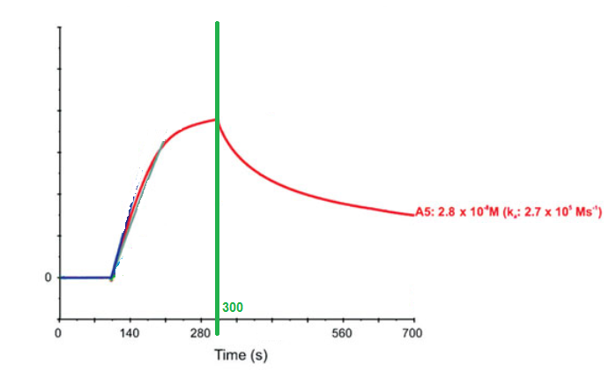
Himanen (2004) used SPR to determine binding constants between a ligand and another tyrosine kinase (EphB5). Those results are displayed in Figure 3. The first part of the curve between 120 and 300 seconds represents ligands being added to the surface, which contains proteins that the ligands can bind to: as more ligand added, more binding occurs. The second part of the curve after 300 seconds represents dissociation of the analyte after the addition is completed. A binding constant can be calculated from the curves (see appendix).
Figure 3. SPR results. The vertical axis represents the change in absorption angle (arbitrary units). Up to 300 seconds (green line), ligand is added to the metal surface, so more binding occurs, and the absorption angle increases. After 300 seconds, no more ligand is added to the solution, and the molecules begin to dissociate. The absorption angle thus starts to change back to near its original value. (Adapted from Himanen, 2004.)
Example SPR Curve
Change in absorption angle
Using Tie-2 and angiopoietins will likely yield similar curves and binding constants as those obtained by Himanen (2004).

Discussion

Complications of SPR
SPR is not without its flaws (Homola, 2003). Because of the sensitive nature of the technique, slight changes on the surface of the gold foil can affect the results. All interactions between molecules and the metal may change the absorption angle of SPR and thus lead to inaccuracies in the data (Schuck, 1997). For example, it is possible that the gold surface used in SPR may have a low affinity for angiopoietins, which would generate higher binding constants. Another possibility is the occurrence of a conformation change of the Tie-2 receptor in the SPR apparatus, which would generate lower binding constants (Shuck, 2010).
Further, determination of binding constants from SPR data is tricky, since there exist confounding effects that are unique to SPR.
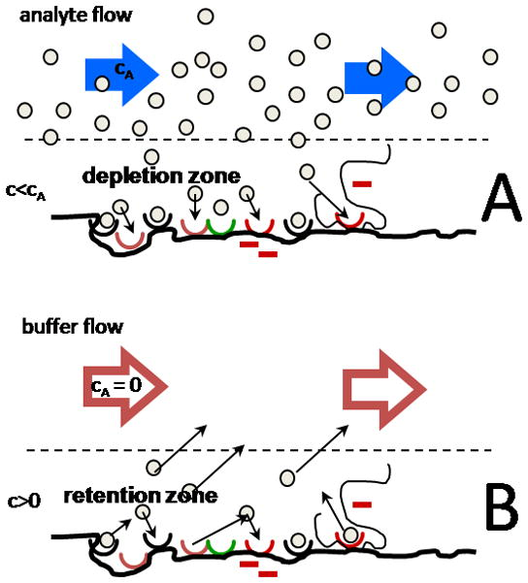
One such effect is the mass transfer limitation (Figure 4) (Shuck, 2010). Two processes occur near the surface with the Tie-2 receptors. Firstly, angiopoietins must diffuse to the Tie-2 receptors (mass transfer). Secondly, the angiopoietins must bind to the Tie-2 receptors. If the binding process is significantly faster than the mass transfer process, the concentration of angiopoietin that is close to Tie-2 (and thus able to bind to Tie-2) will be lower than the expected, creating a “depletion zone”. In other words, Tie-2 may “suck in” angiopoietins faster than they can be replenished, which leads to less accurate SPR results. An analogous effect occurs during the dissociation half of the experiment. The mass transfer effect can be minimized by varying the concentrations of angiopoietins to obtain repeated observations. It is also possible to correct for it through mathematical models, by treating the area near the metal surface as one system, and the area far from the metal surface as another.
Figure 4. Mass transfer limitation. In sub-figure A, a depletion zone is created by Tie-2 binding to angiopoietin faster than angiopoietin can diffuse towards Tie-2. This effect occurs during the addition of angiopoietins. In sub-figure B, a retention zone is created when angiopoietins cannot diffuse away quickly enough before they bind to Tie-2. This effect occurs during the phase of the experiment when an angiopoietin-free buffer is added to the surface. Image from Shuck (2010).
Another effect is the fact that the surface of the gold is not completely flat (Shuck, 2010). This changes the way angiopoietins diffuse across the surface, again, changing the concentration of angiopoietins at the surface of the metal. Mathematical models also exist for the correction of this effect.
These errors are systemic to the technique of SPR, and they only affect the numerical value of the binding constant. In this experiment, we are looking for relative binding, whereas SPR may produce absolute errors. While care will be taken to reduce these errors, they do not affect the conclusions of the experiment.

Scope of the experiment, possible results, and future directions
Considering these limitations, and the fact that the results of SPR are restricted to only show relative binding of each of the angiopoietins, this proposal’s experiment is a first step before more involved experiments can be completed. Knowledge of relative binding can imply the relative effect of each angiopoietin. That understanding can help give more meaningful answers to open questions such as determining the cellular effect of Ang-4. That is, determining whether it is a Tie-2 agonist or antagonist, and resolving which other signaling pathways it triggers. Following knowledge of Ang-4 at the cellular level, in vivo studies can be performed. For example, if Ang-4 is removed in mice, what effect occurs on the capillaries? Is there more or less leakiness in vessels, specifically lung vessels? Are there other defects in the absence of Ang-4? These questions center on the unique effects of Ang-4. Determination of binding affinity is a first step before any of these questions can be answered.
Since Ang-4 seems to localize to the lungs (Valenzuela, 1999), therapy that employs Ang-4 could be more specific to the lungs. A better awareness of Ang-4 could lead to new therapies for the vast number of diseases that rely on or have some effect on the maintenance of blood vessels.

References
Drescher, D. G.; et al. (2010). Surface Plasmon Resonance (SPR) Analysis of Binding Interactions of Proteins in Inner-Ear Sensory Epithelia. Methods in Molecular Biology 493: 323-343. http://www.ncbi.nlm.nih.gov/pmc/articles/PMC2864718/
Gale, N. W.; Yancopoulos, G. D. (1999). Growth factors acting via endothelial cell-specific receptor tyrosine kinases: VEGFs, angiopoietins, and ephrins in vascular development. Genes and Development 13(9): 1055-1056. http://www.ncbi.nlm.nih.gov/pubmed/10323857
Hellmut, G. A.; et al. (2009). Control of vascular morphogenesis and homeostasis through the angiopoietin–Tie system. Nature Reviews Molecular Cell Biology 10, 165-177. http://www.ncbi.nlm.nih.gov/pubmed/19234476
Himanen, J.-P.; et al. (2004). Repelling class discrimination: ephrin-A5 binds to and activates EphB2 receptor signaling. Nature Neuroscience 7(5): 501-509. http://www.ncbi.nlm.nih.gov/pubmed/15107857
Homola, J.; et al. (1999). Surface plasmon resonance sensors: review. Sensors and Actuators B: Chemical 54(1): 3-15. http://www.sciencedirect.com/science/article/pii/S0925400598003219
Jain, R. K. (2003). Molecular regulation of vessel maturation. Nature Medicine 9(6): 685-693. http://www.ncbi.nlm.nih.gov/pubmed/12778167
Kennedy, A.; et al. (2010). Angiogenesis and blood vessel stability in inflammatory arthritis. Arthritis and Rheumatism 62(3): 711-721. http://www.ncbi.nlm.nih.gov/pubmed/20187131
Lee, H. J.; et al. (2004). Biological characterization of angiopoietin-3 and angiopoietin-4. FASEB Journal 18(11): 1200-1208. http://www.ncbi.nlm.nih.gov/pubmed/15284220
O’Shannessy, D. J.; et al. (1993). Determination of rate and equilibrium binding constants for macromolecular interactions using surface plasmon resonance: use of nonlinear least squares analysis methods. Analytical Biochemistry 212(2): 457-468. http://www.ncbi.nlm.nih.gov/pubmed/8214588
Padua, D.; et al. (2008). TGFbeta primes breast tumors for lung metastasis seeding through angiopoietin-like 4. Cell 133(1): 66-77. http://www.ncbi.nlm.nih.gov/pubmed/18394990
Prevete, N.; et al. (2013). Expression and function of Angiopoietins and their tie receptors in human basophils and mast cells. Journal of Biological Regulators and Homeostatic Agents 27(3): 827-839. http://www.ncbi.nlm.nih.gov/pubmed/24152847
Sabban, S. (2011). Development of an in vitro model system for studying the interaction of Equus caballus IgE with its high-affinity FcεRI receptor. Electronic Thesis, University of Sheffield. http://etheses.whiterose.ac.uk/2040/2/Sabban,_Sari.pdf
Shuck, P. (1997). Use of surface plasmon resonance to probe the equilibrium and dynamic aspects of interactions between biological macromolecules. Annual Review of Biophysics and Biomolecular Structure 26:541-566. http://www.ncbi.nlm.nih.gov/pubmed/9241429
Shuck, P.; et al. (2010). The Role of Mass Transport Limitation and Surface Heterogeneity in the Biophysical Characterization of Macromolecular Binding Processes by SPR Biosensing. Methods in Molecular Biology 627: 15-54. http://www.ncbi.nlm.nih.gov/pubmed/20217612
Standiford, T. J.; et al. (1995). Macrophage inflammatory protein-1 alpha mediates lung leukocyte recruitment, lung capillary leak, and early mortality in murine endotoxemia. Journal of Immunology 155(3): 1515-1524. http://www.ncbi.nlm.nih.gov/pubmed/7636213
Terajima, M.; et al. (2007). Immunopathogenesis of hantavirus pulmonary syndrome and hemorrhagic fever with renal syndrome: Do CD8+ T cells trigger capillary leakage in viral hemorrhagic fevers?. Immunology Letters 113(2): 117-120. http://www.ncbi.nlm.nih.gov/pubmed/17897725
Valenzuela, D. M.; et al. (1999). Angiopoietins 3 and 4: Diverging gene counterparts in mice and humans. Proceedings of the National Academy of Sciences of the United States of America 96(5): 1904-1909. http://www.ncbi.nlm.nih.gov/pubmed/10051567

Appendix: SPR angle conversion to binding constant
This derivation is adapted from O’Shannessy, (1993). The Tie-2 and Tie-2-angiopoietin complex is in equilibrium. For simplicity, let Tie-2 alone be A, and the angiopoietin be B. Consider the forward reaction:
$$A+B↔AB$$
Let [X] represent the concentration molecule X. The rate of formation of AB at time t is given by the equation:
$$\frac{d[AB]}{dt}=k_{a}\left[A\right]\left[B\right]-k{}_{d}[AB]$$
Where k_{a} is an association constant, and k_{d} is a dissociation constant. These are reciprocals of each other.
During SPR we are measuring the change in the SPR angle. Let the change in angle be R, for “response”. Central to SPR is that R is proportional to [AB] and -[A], since as more of A reacts, more of AB forms. Substituting R into the above equation:
$$\frac{dR}{dt}=k_{a}\left[B\right]\left(-R\right)-k{}_{d}R \\ \frac{dR}{dt}=-k{}_{a}\left[B\right]R-k_{d}R$$
Since R appears on both sides of the equation, its units don’t matter since they will cancel. dR/dt is the slope of the SPR response. This equals the slope of the curve that is generated by plotting the change in angle against time, as in figure 3. Additionally, [B] is known at any given time because it is controlled by the flow of ligand onto the SPR metal surface. Thus, with the knowledge that they are reciprocals of each other, k_{a} and k_{d} can be calculated. Then, the binding constant k_{b} can also be calculated, because it is defined as k_{d}/k_{a}.

